**SQL TEST**

We have two MySQL database tables as per the details shown below:

1. Employee table is created using the following command:

CREATE TABLE EMPLOYEE (

EMP_ID CHAR(6) NOT NULL,

DEPT_ID CHAR(4) NOT NULL,

FIRST_NAME CHAR(20) NOT NULL,

LAST_NAME CHAR(20),

AGE INT,

SEX CHAR(1),

INCOME FLOAT,

DOJ DATETIME);

The above field names are self-explanatory. However, DOJ field refers to Date of Joining.

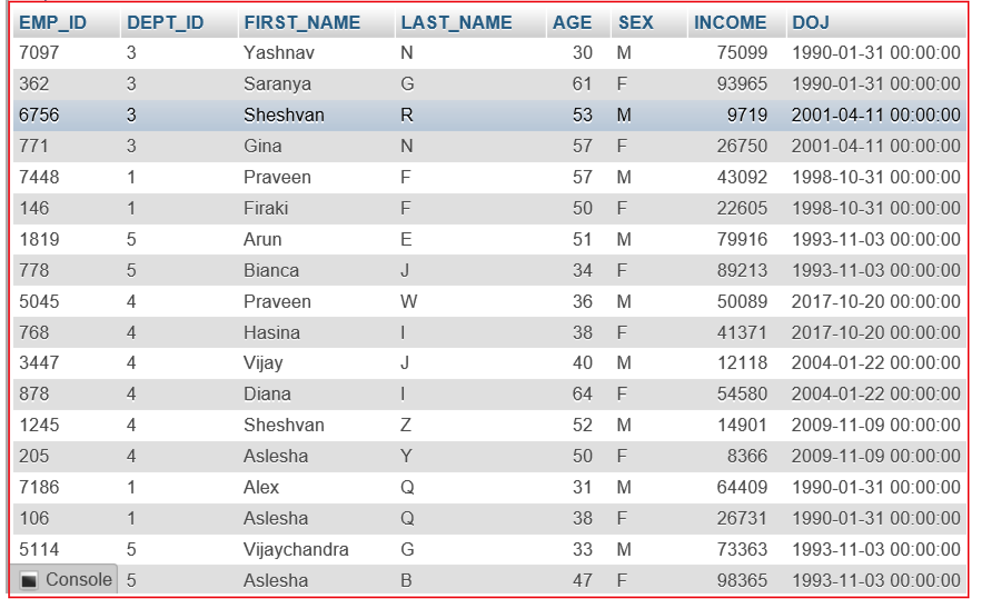

1. Department table is created using the following command:

CREATE TABLE DEPARTMENT(

DEPT_ID CHAR(4) NOT NULL,

DEPT_NAME CHAR(20),

EMP_ID CHAR(6) NOT NULL);

The above field names are self-explanatory.

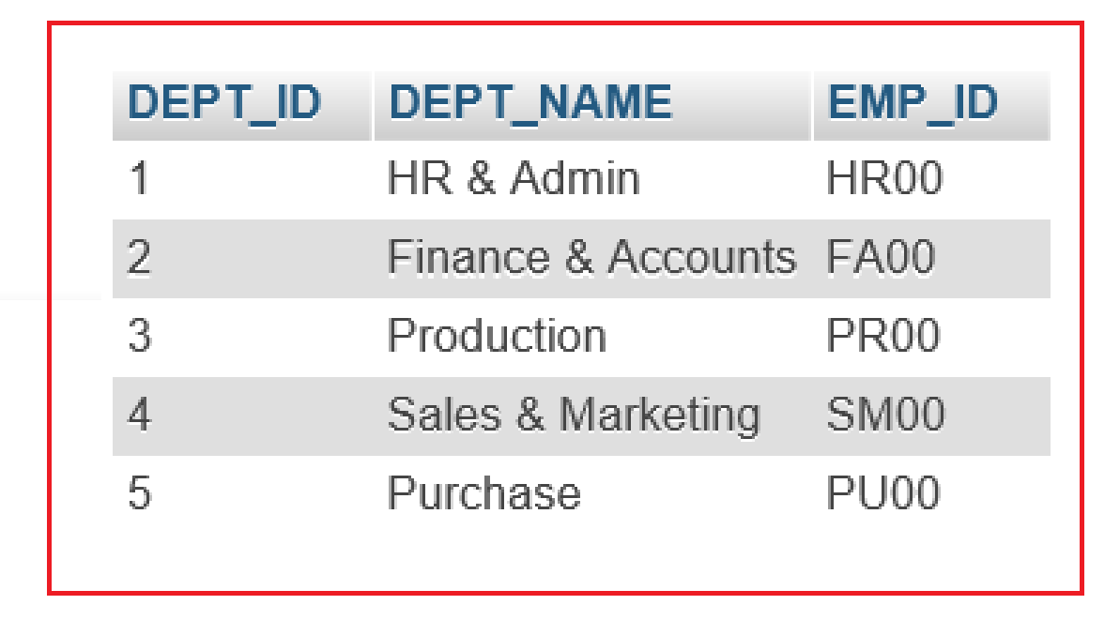

1. Leaves table is created using the following command:

CREATE TABLE IF NOT EXISTS leaves

(

EMP_ID CHAR(6) NOT NULL,

LEAVE_START_DATE DATE,

LEAVE_END_DATE DATE,

LEAVE_DAYS TINYINT NOT NULL);

The above field names are self-explanatory.

